# PERSONAL FINANCE MANAGEMENT

UTPRENA KANSAKAR, SAMIR ACHARYA, SUBHAM SHRESTHA, TEK RAJ SAPKOTA

B.Sc. (Hons.) Computing, Softwarica College of IT and E-commerce, Coventry University

ST4008CEM: Computing Activity Led Learning Project 1

Giriraj Rawat

February 28, 2025

Table of Contents

PERSONAL FINANCE MANAGEMENT 1

INTRODUCTION 4

Purpose and Objectives of the Project 4

AIMS 5

OBJECTIVES 5

PROBLEM STATEMENT 5

FEATURES 6

SOFTWARE REQUIREMENT SPECIFICATIONS 6

Functional Requirements 6

Non-Functional Requirements 6

SCOPE 8

DEVELOPMENT METHODOLOGIES 9

Methodology 9

Tools and technologies 9

SYSTEM ARCHITECTURE 10

PROJECT PLAN 10

PROTOTYPES 11

DEVELOPED SYSTEM 14

APPENDIX 14

Source Code 14

VERSION CONTROL 24

GitHub: 24

CONCLUSION 25

# INTRODUCTION

Managing personal finances effectively is essential for financial stability and long-term growth. Without a proper system in place, individuals may struggle with budgeting, tracking expenses, and achieving their financial goals. A Personal Finance Management (PFM) system helps users gain better control over their income, expenses, savings, and investments. By automating financial tracking and analysis, the system reduces errors, enhances decision-making, and promotes responsible financial habits.

## Purpose and Objectives of the Project

The purpose of this project is to develop a Personal Finance Management (PFM) system that enables users to track, manage, and plan their finances efficiently. The system aims to provide users with insights into their spending patterns, helping them make informed financial decisions. The key objectives of the project include:

* Expense Tracking: Automatically record and categorize expenses.
* Budget Management: Set monthly budgets and track spending against them.
* Income Management: Log various sources of income and manage cash flow.
* Savings & Investment Tracking: Monitor savings goals and investment progress.
* Financial Insights & Reports: Generate reports for better financial planning.

# AIMS

The aim of this integrated system is to provide a user-friendly platform for customers to track their money and keep a record of their finances.

# OBJECTIVES

* Understand and prioritize your financial goals
* Make sure your goals are SMART
* Get into the habit of budgeting
* Track your spending
* Automate your savings and payments

# PROBLEM STATEMENT

Managing personal finances is a common challenge for individuals, leading to overspending, lack of savings, and financial stress. Many users struggle to keep track of their income and expenses due to the complexity of manual budgeting or the high cost of existing finance management tools. Traditional methods, such as spreadsheets or pen-and-paper tracking, are time-consuming, error-prone, and lack automation.

# FEATURES

* **Smart Budgeting:** Personalized budgets based on income and expenses.
* **Savings Goals:** Helps users set and track progress toward financial milestones.
* **Bill Reminders:** Ensures users never miss due dates, avoiding late fees.

.

# SOFTWARE REQUIREMENT SPECIFICATIONS

The Software Requirements Specification (SRS) serves as a detailed guide for software development, ensuring clarity, accuracy, and collaboration among developers and stakeholders. Adhering to IEEE standards, it aligns technical robustness with business objectives and industry norms, optimizing efficiency, responsiveness, and security while mitigating risks for cost-effective solutions.

## Functional Requirements

Functional requirements specify the expected operations and behaviors of a software system, integral to requirements engineering.

* User Registration and Authentication
* Expense Tracking
* Budget Management
* Savings Goals
* Reports and Analytics
* Security and Data Protection
* User-Friendly Interface

## Non-Functional Requirements

Nonfunctional requirements guarantee the overall quality and effectiveness of a software system.

* Performance Requirements
* Security Requirements
* Usability Requirements
* Scalability Requirements
* Availability & Reliability Requirements
* Maintainability & Upgradability Requirements
* Compliance Requirements

# SCOPE

* Expense Tracking: Users can manually input or automatically sync transactions from bank accounts to categorize and track expenses.
* Budgeting: Users can set monthly, weekly, or custom budgets and track expenses against them.
* Savings Goals: Users can create, track, and manage savings goals for specific purposes, like emergency funds or vacations.
* Platform Compatibility
* Integration with MySQL and other databases.
* User Interface and Experience
* Scalability
* User Data Security

# DEVELOPMENT METHODOLOGIES

The Personal Finance Management App will follow a structured and systematic approach to ensure that all aspects of the app’s design, development, and functionality are well-documented. This will help both developers and end-users by providing clear, organized, and easily accessible information.

## Methodology

Agile methodology is an iterative approach to software development that emphasizes flexibility, collaboration, and customer feedback. In the context of the Personal Finance Management App, Agile will enable the development team to work in incremental cycles (sprints), continuously improving the product based on user needs and feedback.

## Tools and technologies

Software development tools are specialized programs or applications crafted to aid developers in creating and testing software. They serve as indispensable resources for both seasoned programmers by simplifying intricate coding tasks and assisting in debugging. Some of the tools and technologies used are mentioned below:

* Python
* Visual Studio Code

# SYSTEM ARCHITECTURE

The Personal Finance Management (PFM) App follows a three-tier architecture, ensuring modularity, scalability, and maintainability. The system is divided into three primary layers:

* Presentation Layer (Frontend)
* Business Logic Layer (Backend)
* Data Layer (Database & Storage)

# PROJECT PLAN

The Personal Finance Management (PFM) App is designed to help users track their income, expenses, and savings efficiently. The project follows an Agile methodology, allowing continuous improvements based on user feedback.

# PROTOTYPES

# DEVELOPED SYSTEM

The Personal Finance Management (PFM) App is a comprehensive solution developed using Python for both the frontend and backend. The system is designed to offer a user-friendly interface, secure data management, and powerful financial features.

# APPENDIX

## Source Code

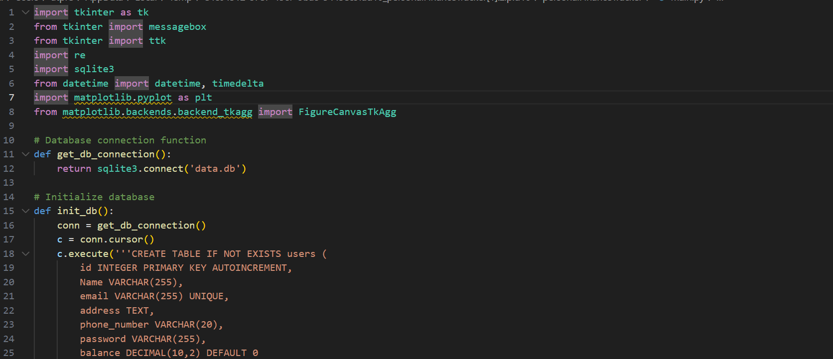

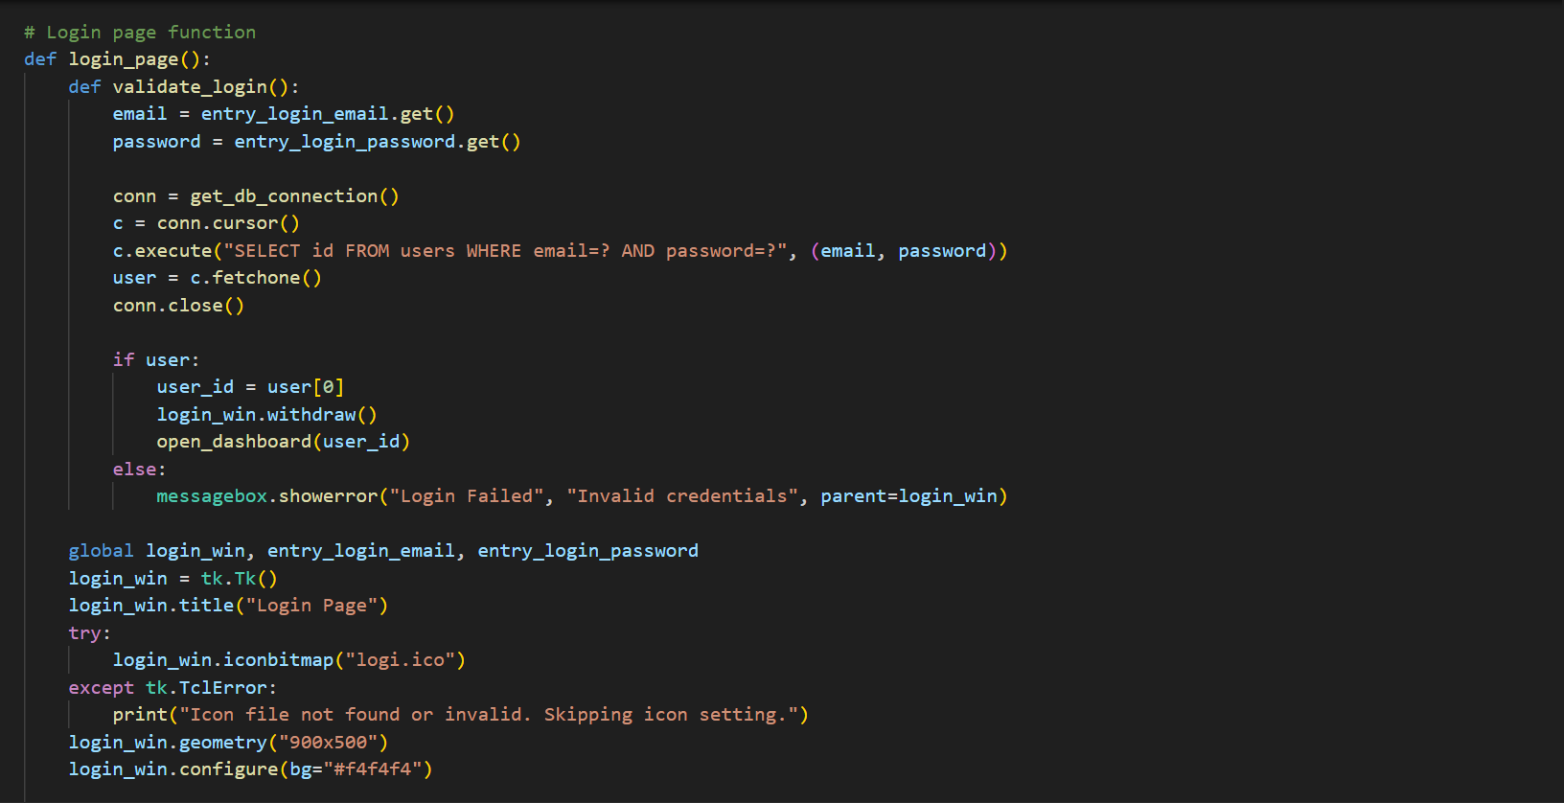

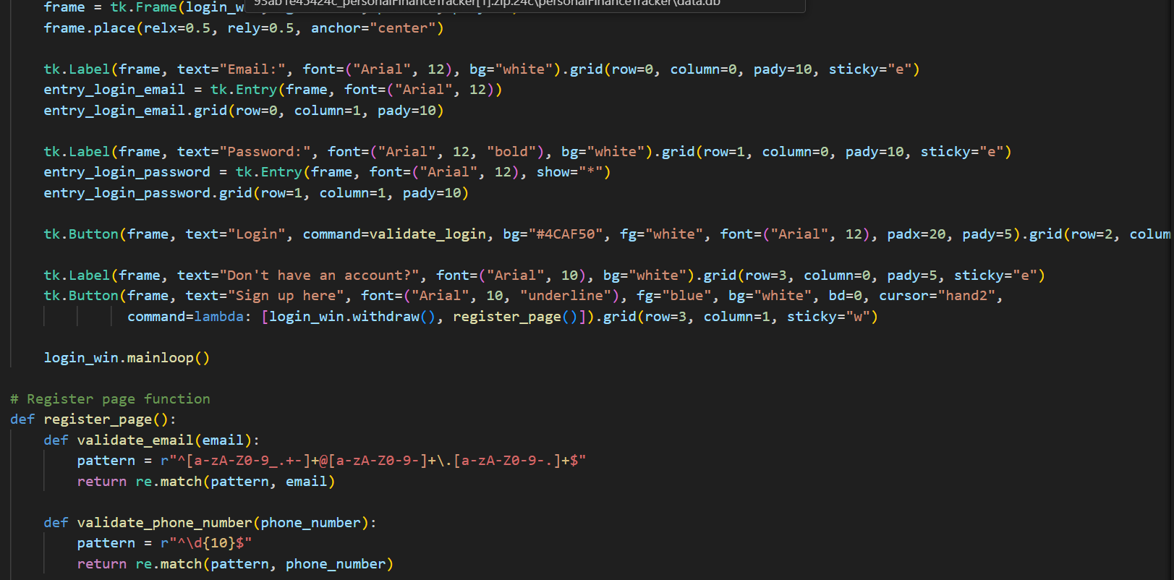

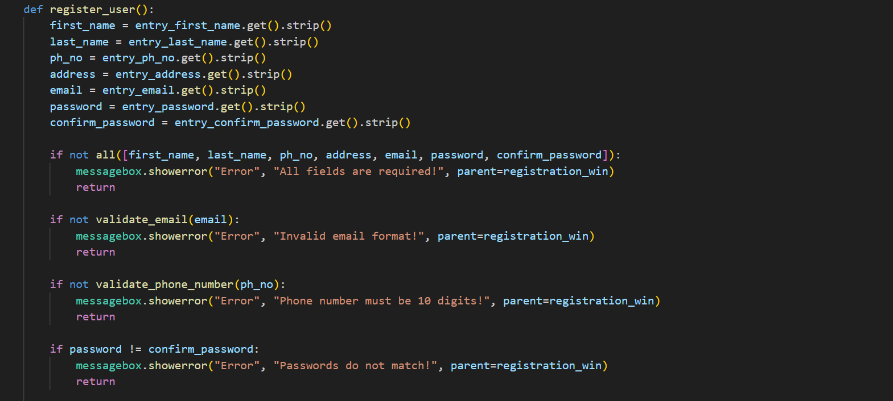

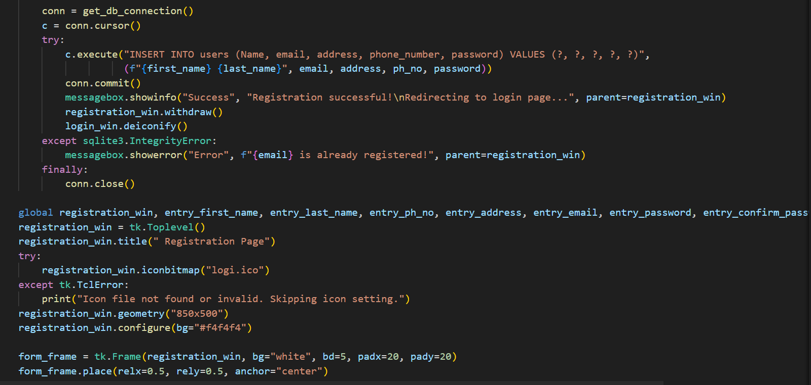

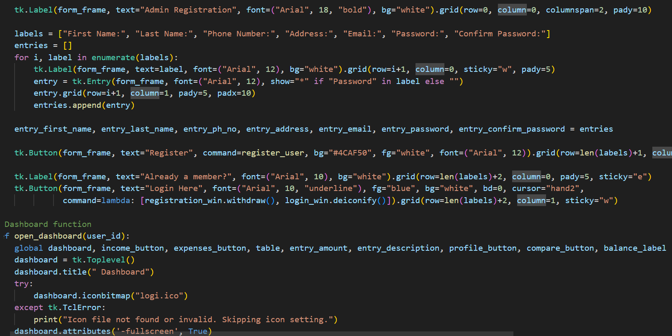

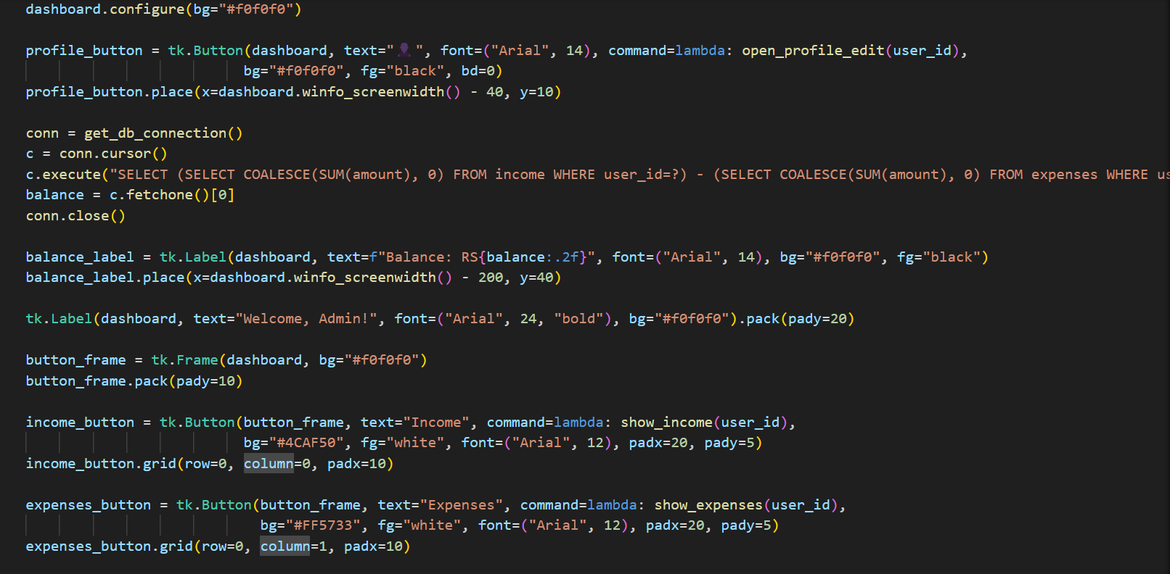

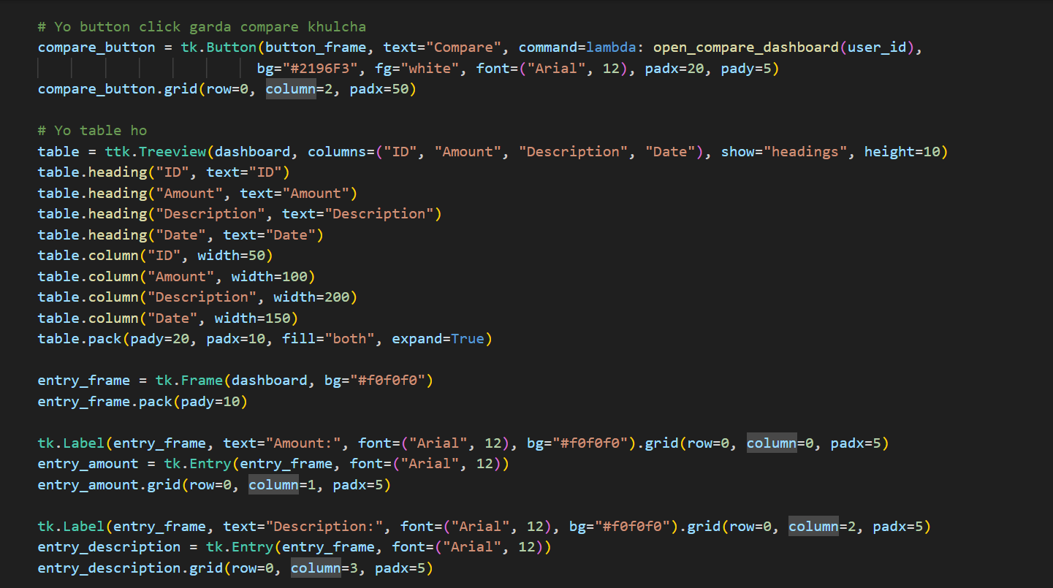

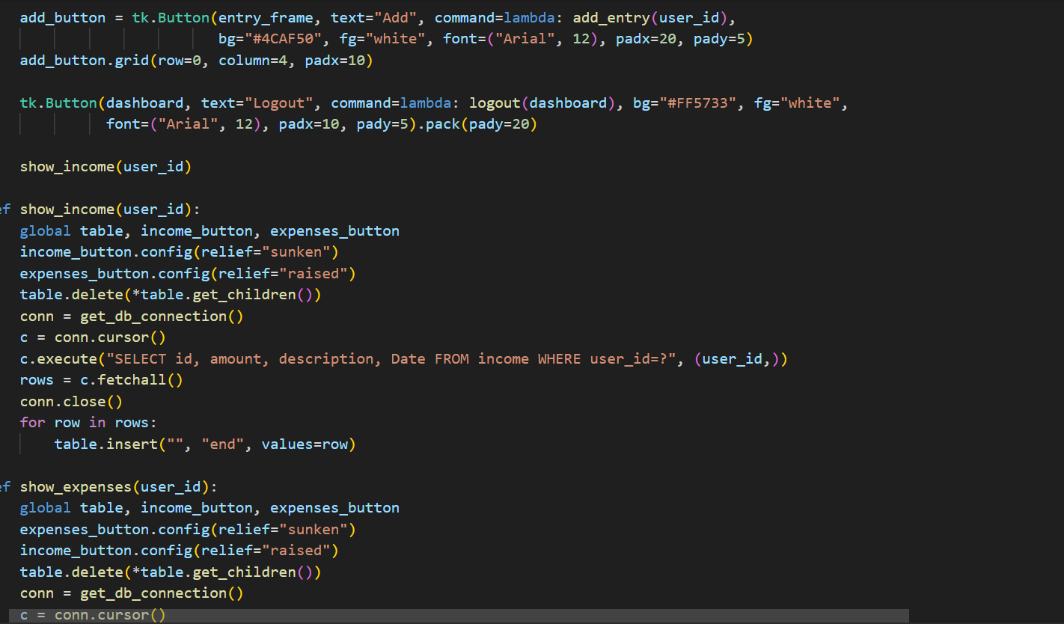

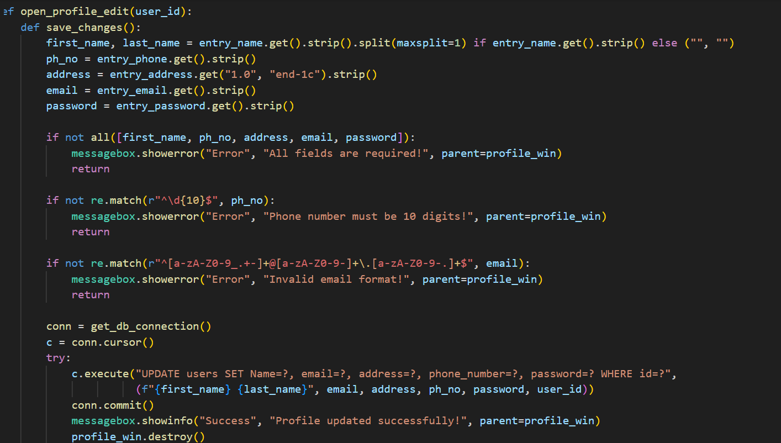

# VERSION CONTROL

## GitHub:

Link: *https://github.com/bikesh-khatri/utprenaandgroup.git*

# CONCLUSION

The Personal Finance Management (PFM) App provides users with a simple yet powerful tool for managing their finances. Through the use of a Python-based stack the app is designed to offer both frontend and backend solutions that ensure smooth user interaction, robust data management, and secure financial tracking.